Project group members:

Benjamin Cobb

Justin Dupuis

**README**

In order to run this program, simply run: python pwMan-template.py [websitenamegoeshere]. The password for the supplied website name will be returned (assuming it already exists in the database). If a password doesn’t already exist for the given website, you will receive the prompt to enter your own or store a randomly generated one, pressing ‘y’ or ‘n’ to indicate your choice.

On the very first startup of the program, there will be no master password, and the program will prompt the user for one. This is the only password that the user needs to remember, since all others can be retrieved with the master password through the program.

**Screenshots:**

The screenshot shows both the statement that will appear when a user incorrectly executes the program (without passing any arguments as input), as well as the initial password database creation that will occur whenever a user executes the program for the first time.

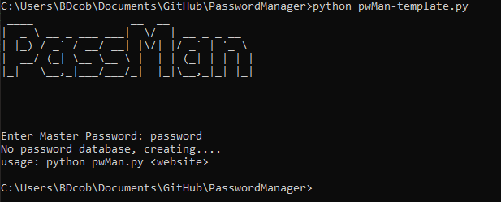

This screenshot demonstrates two things: First, it demonstrates the creation of a new password, prompting the user for their own defined password or the ability to generate a random one.

Second, the console output demonstrates a user retrieving an existing password for a website that has already been registered in the password database.

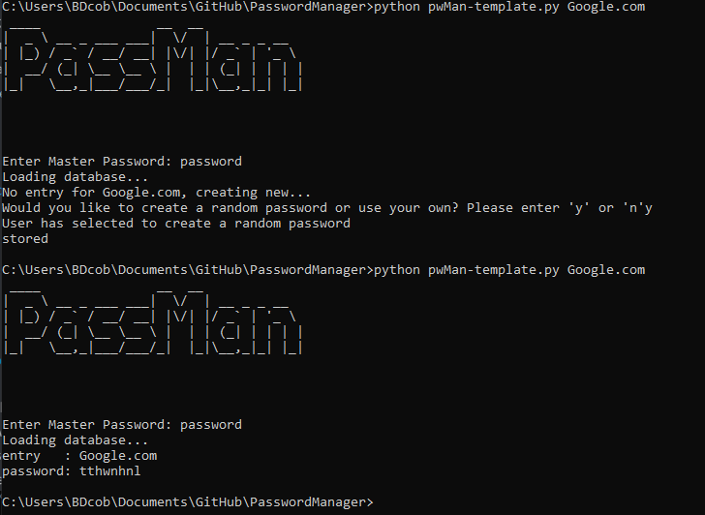

This screenshot demonstrates a user creating their own password instead of having their password randomly generated. The next console output shows the successful retrieval of the user-created password.

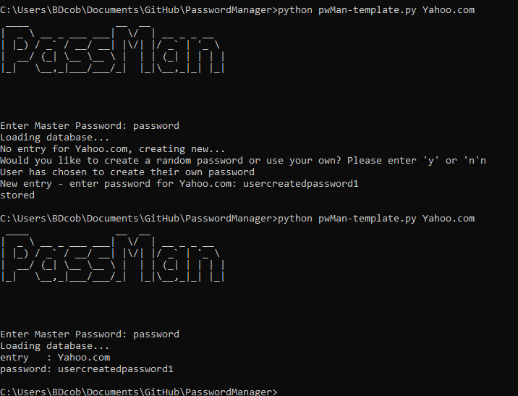

References:

https://pynative.com/python-generate-random-string/